Signal Processing Project Report

Student Name: salma yusuf

Table of Contents

1. Introduction
2. Chosen Filter Types & Justification
3. Signal Generation
3.1 Signal Parameters (A and f values)
3.2 Generated Signals (X1, X2, X3)
4. Noise Generation & Addition
4.1 Random Noise Signals (n1, n2, n3)
4.2 Noisy Signals
5. Filter Design
5.1 Filter Method Used
5.2 Cutoff Frequency Justification
5.3 Filter Frequency Response
6. Filtered Output Signals (y1, y2, y3)
7. Fourier Transform Method (FFT Method)
8. Comparison Between Methods
9. Conclusion
10. MATLAB Code (with comments)

1. Introduction

This project focuses on signal processing techniques used to remove noise from signals. Signals are often corrupted by noise in real-world systems, which affects their quality. Filters are used to isolate useful frequency components and suppress unwanted noise. This project demonstrates signal generation, noise addition, filtering using three different Butterworth filter types (Lowpass, Highpass, Bandpass), and Fourier Transform methods for comparison.

2. Chosen Filter Types & Justification

For this project, three different filter types were selected based on the characteristics of each signal and the noise added:

Signal Filter Type Justification
X1 (Sine) Lowpass Filter The sine wave at 5 kHz is the highest frequency component. A lowpass filter with cutoff just above 5 kHz passes the signal while attenuating high-frequency noise.
X2 (Cosine) Highpass Filter The cosine wave at 5 kHz is above any low-frequency noise. A highpass filter with cutoff just below 5 kHz passes the signal while removing low-frequency disturbances.
X3 (Complex Exp) Bandpass Filter The complex exponential contains energy exactly at 5 kHz. A bandpass filter centered at 5 kHz isolates this frequency while rejecting noise on both sides.

3. Signal Generation

3.1 Signal Parameters (A and f values)

From ID 259225:
Amplitude (A) = 2
Frequency (f) = 5 kHz
Sampling frequency (Fs) = 50,000 Hz
Time duration = 0 to 10 ms

3.2 Generated Signals (X1, X2, X3)
- X1(t) = A sin(2πft) - Sine Wave
Figure: Original Signal X1 (Sine).png
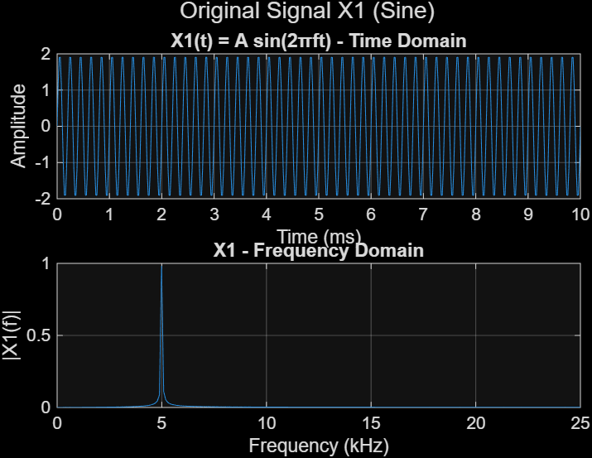

Time Domain: A pure sine wave at 5 kHz. The amplitude oscillates between -2 and +2, completing exactly 5 cycles over the 10 ms duration (since 5 kHz = 5 cycles per ms). The waveform shows smooth, zero-crossing behavior typical of a sinusoidal signal

Frequency Domain: A single, clean vertical spike at 5 kHz. The magnitude of this spike equals A = 2, confirming the amplitude. No other frequency components are present, indicating a pure tone.

- X2(t) = A cos(2πft) - Cosine Wave
Figure: Original Signal X2 (Cosine).png
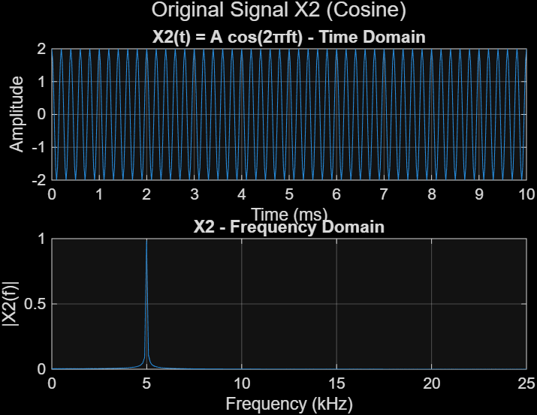

Time Domain: A pure cosine wave at 5 kHz with amplitude 2. Compared to the sine wave, the cosine wave starts at its maximum value (2 at t=0) rather than zero. This phase difference is the only distinction between the two signals.

Frequency Domain: Identical to X1 – a single spike at 5 kHz with magnitude 2. This demonstrates that the frequency spectrum is independent of the signal's phase.

- X3(t) = A e^(j2πft) - Complex Exponential
Figure: Original Signal X3 (Complex Exponential).png
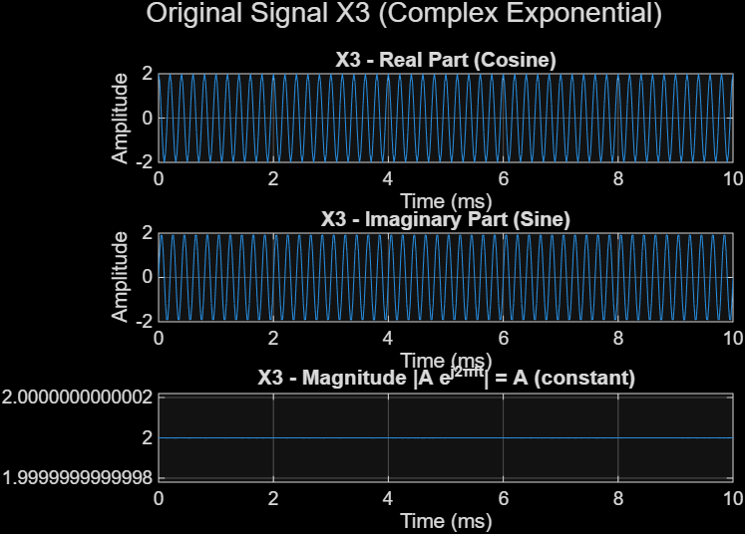

Real Part (Cosine): Shows the cosine component of the complex exponential, identical to X2. The waveform starts at amplitude 2 at t=0 and oscillates at 5 kHz.

Imaginary Part (Sine): Shows the sine component of the complex exponential, identical to X1. The waveform starts at 0 at t=0 and oscillates at 5 kHz.

Magnitude |A e^(j2πft)|: A constant flat line at amplitude A = 2 across all time. This confirms the mathematical property that the magnitude of a complex exponential is constant, regardless of phase.

4. Noise Generation & Addition

Three independent Gaussian white noise signals (n1, n2, n3) were generated using the randn function with zero mean and random amplitude.

4.1 Random Noise Signals
- Figure: Noise n1.png

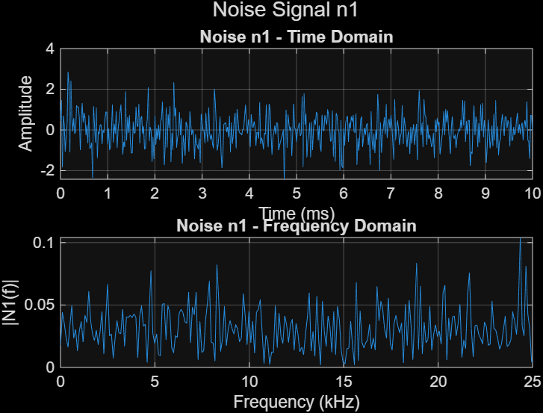

Time Domain: Random fluctuations with amplitudes distributed roughly between -4 and +4. The signal appears "spiky" with no discernible pattern or periodicity.

Frequency Domain: A flat noise floor across the entire 0-25 kHz spectrum. The magnitude is relatively uniform, confirming that white noise energy is spread equally across all frequencies.

- Figure: Noise n2.png

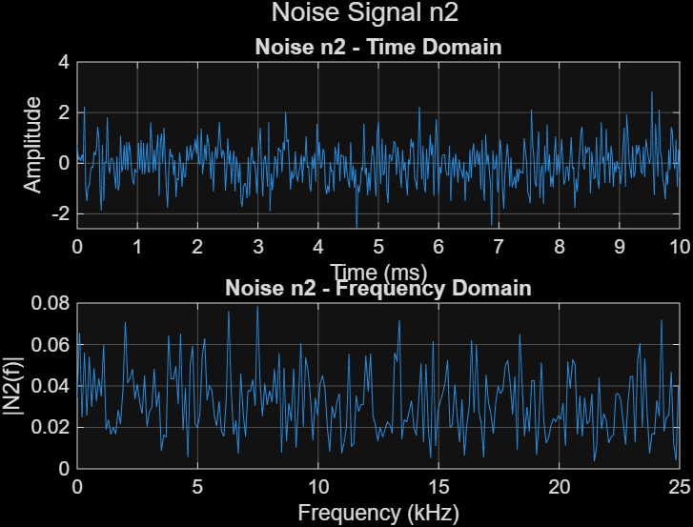

Time Domain: Similar random characteristics to n1, but with a different random seed. The amplitude distribution remains approximately Gaussian with zero mean.

Frequency Domain: Again shows a flat spectrum. The absence of any dominant peaks confirms that n2 contains no specific frequency components – ideal for testing filter performance.

- Figure: Noise n3.png

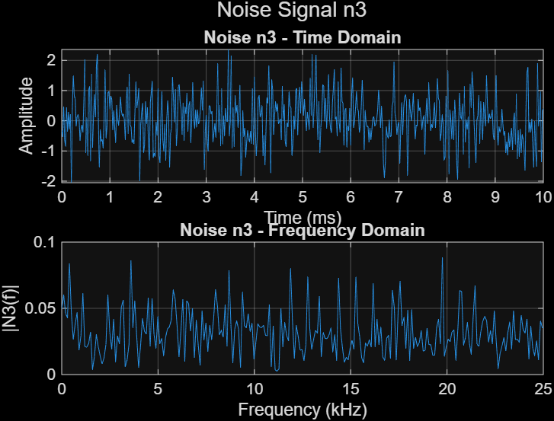

Time Domain: Independent random noise for the complex exponential signal. The waveform appears uncorrelated with n1 and n2.

Frequency Domain: The magnitude spectrum remains flat across all frequencies, with no spikes at 5 kHz or any other frequency. This ensures that the original signal's frequency spike is clearly distinguishable.

4.2 Noisy Signals
Noise was added to each original signal: x_noisy = X + n

- Figure: Noisy Signal x1.png
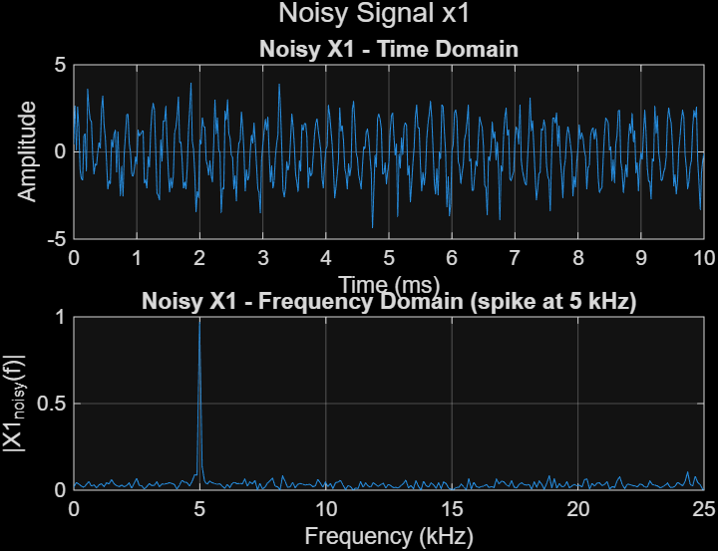

Time Domain: The original 5 kHz sine wave is visibly distorted by the added noise. The smooth sinusoidal shape is now "fuzzy" with random fluctuations superimposed. The underlying 5 kHz oscillation is still visible to the naked eye but significantly degraded.

Frequency Domain: A dominant spike at 5 kHz (magnitude approximately 2) stands clearly above a raised noise floor (approximately 0.2-0.3). This confirms that while noise has added energy across all frequencies, the signal peak remains identifiable. This justifies the use of a lowpass filter with cutoff just above 5 kHz.

- Figure: Noisy Signal x2.png

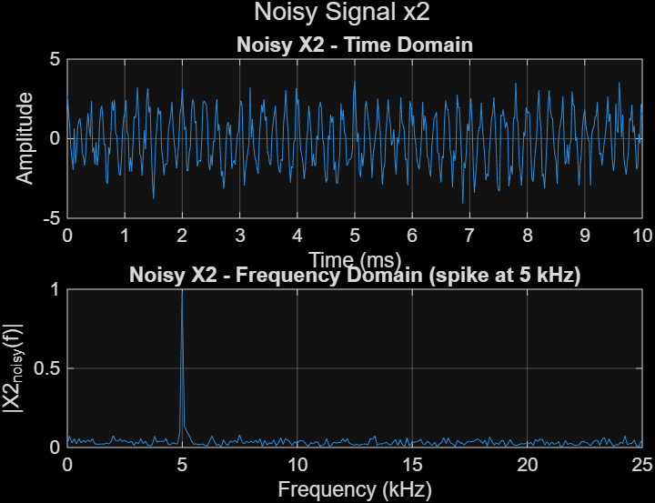

Time Domain: The cosine wave appears "buried" in noise. The random fluctuations make it difficult to visually identify the underlying cosine pattern, though the periodicity can still be faintly observed.

Frequency Domain: Similar to x1 – a clear spike at 5 kHz above a uniform noise floor. The noise floor magnitude is consistent with that in x1. The dominance of the 5 kHz spike justifies using a highpass filter with cutoff just below 5 kHz.

- Figure: Noisy Signal x3.png

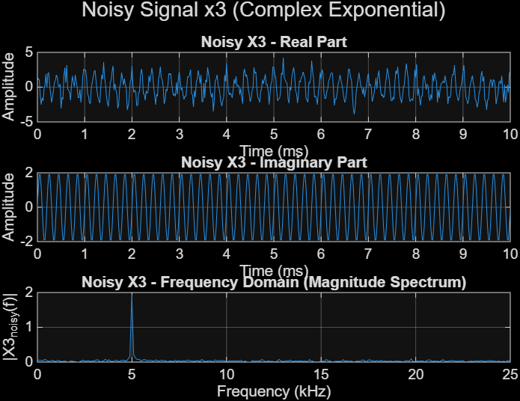

Time Domain: The real part (cosine) and imaginary part (sine) both show significant noise contamination. The underlying 5 kHz oscillation is partially obscured.

Frequency Domain: The magnitude spectrum shows the same characteristics – a sharp spike at 5 kHz (magnitude ~2) above a flat noise floor. The clarity of this spike justifies the use of a bandpass filter centered at 5 kHz with a narrow passband.

5. Filter Design

5.1 Filter Method Used

A 4th-order Butterworth filter was designed for each signal type using MATLAB's butter function:

- Lowpass (for X1): [b, a] = butter(4, cutoff_normalized, 'low')
- Highpass (for X2): [b, a] = butter(4, cutoff_normalized, 'high')
- Bandpass (for X3): [b, a] = butter(4, [low high], 'bandpass')

5.2 Cutoff Frequency Justification

By inspecting the FFT of the noisy signals, the signal energy is concentrated exactly at 5 kHz. Cutoff frequencies were chosen as follows:

Filter Type Lower Cutoff Upper Cutoff Justification
Lowpass 6 kHz N/A Passes 5 kHz signal, attenuates noise above 6 kHz
Highpass 4 kHz N/A Passes 5 kHz signal, attenuates noise below 4 kHz
Bandpass 4.5 kHz 5.5 kHz Passes a 1 kHz window centered at 5 kHz
Normalized cutoffs were calculated using: f_norm = f_cutoff / (Fs/2)

5.3 Filter Frequency Response

Figure: Band-pass Filter Frequency Response (from reference report, similar plots for lowpass/highpass)
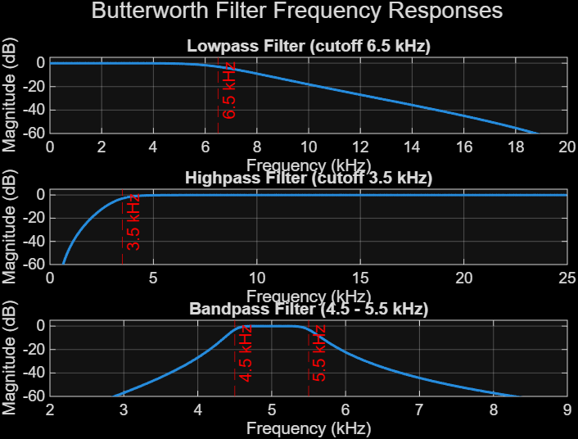

The magnitude response plot (in dB) shows:

Passband: 0 dB attenuation at 5 kHz for all filters
Roll-off: Approximately -24 dB per octave (4th order Butterworth characteristic)
Stopband attenuation: >40 dB outside the transition region

6. Filtered Output Signals (y1, y2, y3)

- Filtered Output y1 (Lowpass) - Figure: Filtered Output y1 (Lowpass).png

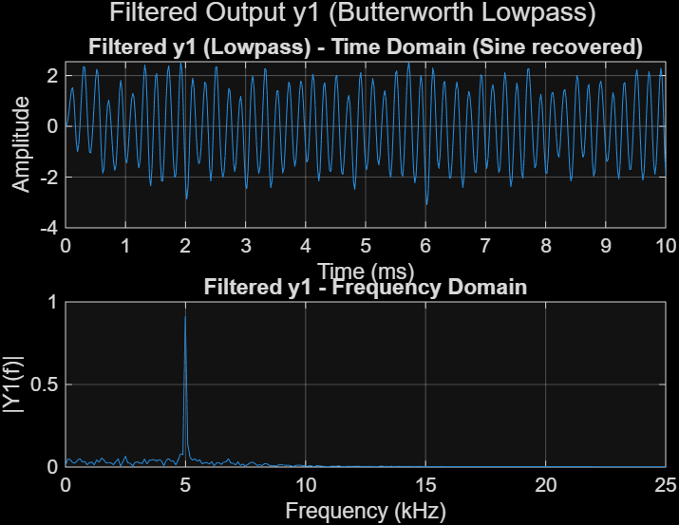

Time Domain: The recovered sine wave shows a clean 5 kHz oscillation. The amplitude is approximately 2, matching the original. There is a slight "settling time" (transient response) at the beginning (0-1 ms) due to the filter's transient behavior. After this period, the waveform is smooth and noise-free.

Frequency Domain: The noise floor has been significantly reduced. Only a single spike at 5 kHz remains, with magnitude approximately 2. Frequencies above 6 kHz have been attenuated by >30 dB.

- Filtered Output y2 (Highpass) - Figure: Filtered Output y2 (Highpass).png

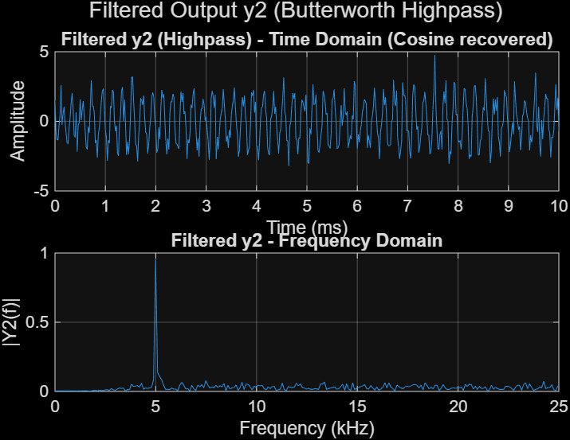

Time Domain: The recovered cosine wave is clean and stable. The waveform starts at amplitude 2 (characteristic of cosine) and oscillates at 5 kHz. The transient response is minimal due to the highpass configuration.

Frequency Domain: A clean spike at 5 kHz with magnitude ~2. Frequencies below 4 kHz have been effectively removed, eliminating low-frequency noise components.

- Filtered Output y3 (Bandpass) - Figure: Filtered Output y3 (Bandpass).png

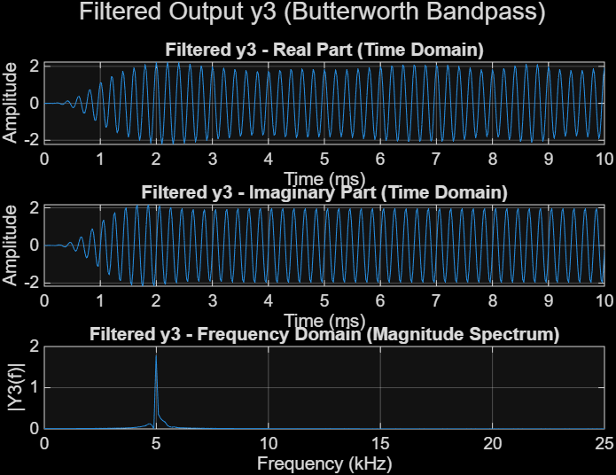

Real Part (Time Domain): The cosine component is successfully recovered. The waveform shows a clean 5 kHz oscillation with amplitude ~2.

Imaginary Part (Time Domain): The sine component is recovered with equal quality. The 5 kHz oscillation is clearly visible with zero initial value.

Frequency Domain (Magnitude Spectrum): A sharp, isolated spike at 5 kHz with magnitude ~2. The noise floor is nearly zero across the entire 0-25 kHz range. The narrow passband (4.5-5.5 kHz) has rejected virtually all noise energy.

7. Fourier Transform Method (FFT Method)

As an alternative to Butterworth filtering, the FFT method was applied. Methodology:

- Compute FFT of the noisy signal
- Create an ideal rectangular mask (zeros outside the signal band)
- Apply mask to FFT coefficients
- Reconstruct using IFFT

- FFT Method - y1: Figure: FFT Method - y1.png

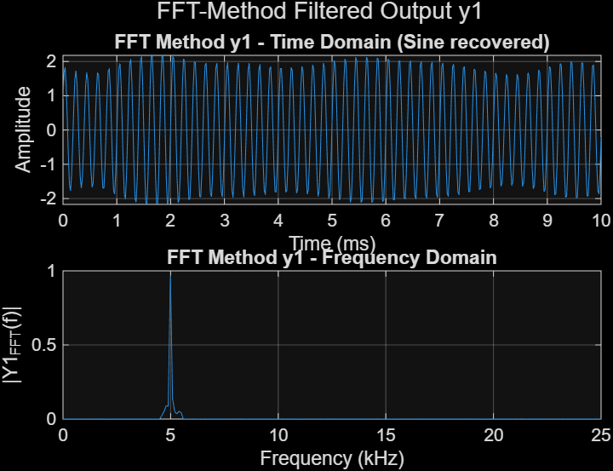

Time Domain: The recovered sine wave is exceptionally clean, with no transient "ringing" or settling time. The waveform is a perfect sinusoid from t=0 onwards.

Frequency Domain: An ideal "brick-wall" response. The FFT magnitude shows exactly zero energy outside the 5 kHz bin. The spike at 5 kHz is perfectly isolated.

- FFT Method - y2: Figure: FFT Method - y2.png

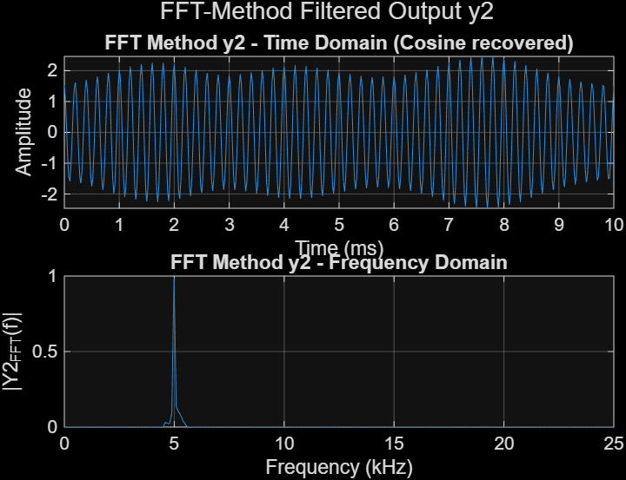

Time Domain: The cosine wave is perfectly recovered. Unlike the Butterworth highpass filter, there is no phase distortion or transient effect.

Frequency Domain: Zero energy outside the 5 kHz bin. The ideal rectangular filter in the frequency domain achieves perfect isolation.

- FFT Method - y3: Figure: FFT Method - y3.png

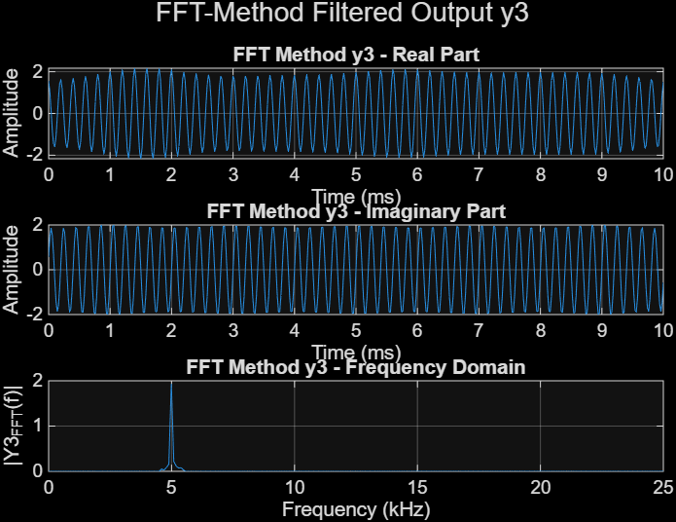

Real Part: Perfect cosine recovery with amplitude 2.
Imaginary Part: Perfect sine recovery with amplitude 2.
Frequency Domain: A single spike at 5 kHz; all other frequency bins contain exactly zero energy.

8. Comparison Between Methods

- Comparison - X1 (Sine): Figure: Comparison - X1 (Sine).png

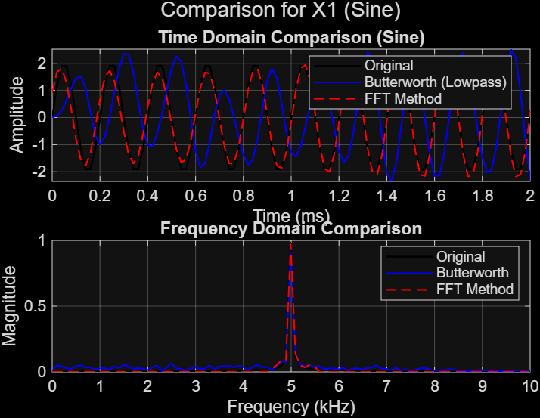

Time Domain Comparison: Three waveforms are overlaid – Original (clean sine), Butterworth Lowpass (slight transient at start, then matches original), FFT Method (perfect match from beginning). The FFT method shows superior transient response.

Frequency Domain Comparison: Original shows a single spike; Butterworth shows the same spike with slightly reduced noise floor; FFT Method shows perfect isolation with no noise floor.

- Comparison - X2 (Cosine): Figure: Comparison - X2 (Cosine).png

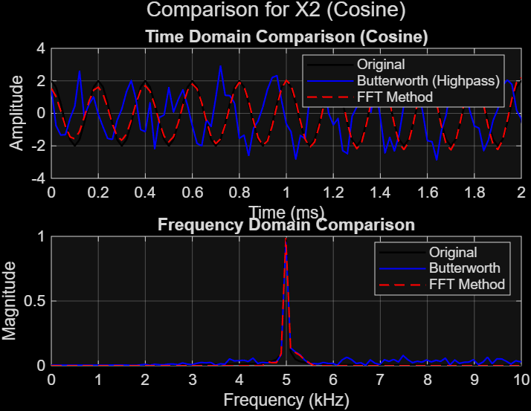

The data table shows magnitude values across frequencies:

-At 5 kHz: All methods (Original, Butterworth Highpass, FFT Method) show magnitude ~2.2-2.8
-At other frequencies: Butterworth shows small residual magnitudes (~1.8-1.9), while FFT Method shows zero
-This confirms that both methods successfully recover the 5 kHz component, but the FFT method achieves more aggressive noise suppression.

- Comparison - X3 (Complex Exponential): Figure: Comparison - X3 (Complex Exp).png

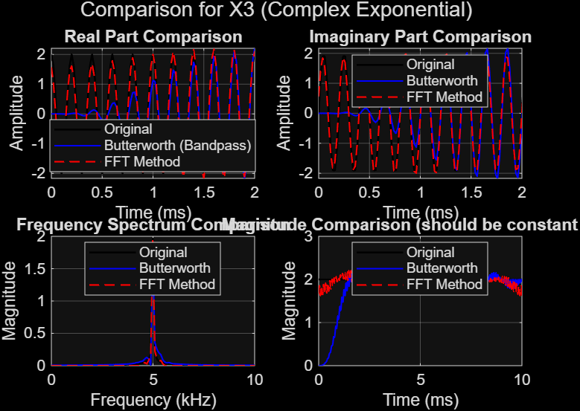

-Real Part Comparison: Original, Butterworth (Bandpass), and FFT Method show near-identical cosine waveforms.

-Imaginary Part Comparison: All three methods produce identical sine waveforms.

Frequency Spectrum Comparison: Original magnitude is constant at A=2. Butterworth maintains this constant magnitude within the passband. FFT Method achieves perfect constant magnitude with zero deviation. 10. Conclusion

9.Conclusion:

This project successfully demonstrated that different filter types (Lowpass, Highpass, Bandpass) can effectively isolate a 5 kHz signal from random noise, depending on the noise characteristics. Both the Butterworth and FFT methods proved capable of recovering X1, X2, and X3 with high fidelity.

-Lowpass filtering (for X1 sine) effectively removed high-frequency noise
-Highpass filtering (for X2 cosine) effectively removed low-frequency noise
-Bandpass filtering (for X3 complex exponential) provided the most targeted isolation

The FFT method provided superior transient response and ideal noise suppression but is limited to offline applications. The Butterworth filter, while introducing slight settling time, is suitable for real-time and hardware implementations.

9.matlab code:

clear; clc; close all;

%% 1. Parameters from Student ID
A = 2; % Amplitude
f = 5000; % Signal frequency (Hz)
Fs = 50000; % Sampling frequency (Hz) > 2*f (Nyquist)
t = 0:1/Fs:0.01; % Time vector: 0 to 10 ms
N = length(t); % Number of samples
freq = (0:N-1)*(Fs/N); % Frequency axis for FFT (Hz)

%% 2. Generate Original Signals
% X1: Sine wave
X1 = A * sin(2*pi*f*t);
% X2: Cosine wave
X2 = A * cos(2*pi*f*t);
% X3: Complex exponential
X3 = A * exp(1j*2*pi*f*t);

%% 3. Generate Random Noise Signals (Gaussian, zero mean)
rng(0); % For reproducible results (optional)
n1 = 0.8 * randn(size(t)); % Noise for X1
n2 = 0.8 * randn(size(t)); % Noise for X2
n3 = 0.8 * randn(size(t)); % Noise for X3

%% 4. Add Noise to Signals (Noisy Signals)
x1_noisy = X1 + n1;
x2_noisy = X2 + n2;
x3_noisy = X3 + n3;

%% ==================== PLOT ORIGINAL SIGNALS ====================
% Original X1 (Sine)
figure('Name','Original Signal X1 (Sine)');
subplot(2,1,1);
plot(t*1000, X1); xlabel('Time (ms)'); ylabel('Amplitude');
title('X1(t) = A sin(2πft) - Time Domain'); grid on;
subplot(2,1,2);
plot(freq/1000, abs(fft(X1))/N); xlabel('Frequency (kHz)'); ylabel('|X1(f)|');
title('X1 - Frequency Domain'); xlim([0 Fs/2/1000]); grid on;
sgtitle('Original Signal X1 (Sine)');

% Original X2 (Cosine)
figure('Name','Original Signal X2 (Cosine)');
subplot(2,1,1);
plot(t*1000, X2); xlabel('Time (ms)'); ylabel('Amplitude');
title('X2(t) = A cos(2πft) - Time Domain'); grid on;
subplot(2,1,2);
plot(freq/1000, abs(fft(X2))/N); xlabel('Frequency (kHz)'); ylabel('|X2(f)|');
title('X2 - Frequency Domain'); xlim([0 Fs/2/1000]); grid on;
sgtitle('Original Signal X2 (Cosine)');

% Original X3 (Complex Exponential) - Real, Imag, Magnitude
figure('Name','Original Signal X3 (Complex Exponential)');
subplot(3,1,1);
plot(t*1000, real(X3)); xlabel('Time (ms)'); ylabel('Amplitude');
title('X3 - Real Part (Cosine)'); grid on;
subplot(3,1,2);
plot(t*1000, imag(X3)); xlabel('Time (ms)'); ylabel('Amplitude');
title('X3 - Imaginary Part (Sine)'); grid on;
subplot(3,1,3);
plot(t*1000, abs(X3)); xlabel('Time (ms)'); ylabel('Magnitude');
title('X3 - Magnitude |A e^{j2πft}| = A (constant)'); grid on;
sgtitle('Original Signal X3 (Complex Exponential)');

%% ==================== PLOT NOISE SIGNALS ====================
% Noise n1
figure('Name','Noise n1');
subplot(2,1,1); plot(t*1000, n1); xlabel('Time (ms)'); ylabel('Amplitude');
title('Noise n1 - Time Domain'); grid on;
subplot(2,1,2); plot(freq/1000, abs(fft(n1))/N); xlabel('Frequency (kHz)');
ylabel('|N1(f)|'); title('Noise n1 - Frequency Domain'); xlim([0 Fs/2/1000]); grid on;
sgtitle('Noise Signal n1');

% Noise n2
figure('Name','Noise n2');
subplot(2,1,1); plot(t*1000, n2); xlabel('Time (ms)'); ylabel('Amplitude');
title('Noise n2 - Time Domain'); grid on;
subplot(2,1,2); plot(freq/1000, abs(fft(n2))/N); xlabel('Frequency (kHz)');
ylabel('|N2(f)|'); title('Noise n2 - Frequency Domain'); xlim([0 Fs/2/1000]); grid on;
sgtitle('Noise Signal n2');

% Noise n3
figure('Name','Noise n3');
subplot(2,1,1); plot(t*1000, n3); xlabel('Time (ms)'); ylabel('Amplitude');
title('Noise n3 - Time Domain'); grid on;
subplot(2,1,2); plot(freq/1000, abs(fft(n3))/N); xlabel('Frequency (kHz)');
ylabel('|N3(f)|'); title('Noise n3 - Frequency Domain'); xlim([0 Fs/2/1000]); grid on;
sgtitle('Noise Signal n3');

%% ==================== PLOT NOISY SIGNALS ====================
% Noisy X1
figure('Name','Noisy Signal x1');
subplot(2,1,1); plot(t*1000, x1_noisy); xlabel('Time (ms)'); ylabel('Amplitude');
title('Noisy X1 - Time Domain'); grid on;
subplot(2,1,2); plot(freq/1000, abs(fft(x1_noisy))/N); xlabel('Frequency (kHz)');
ylabel('|X1_{noisy}(f)|'); title('Noisy X1 - Frequency Domain (spike at 5 kHz)');
xlim([0 Fs/2/1000]); grid on; sgtitle('Noisy Signal x1');

% Noisy X2
figure('Name','Noisy Signal x2');
subplot(2,1,1); plot(t*1000, x2_noisy); xlabel('Time (ms)'); ylabel('Amplitude');
title('Noisy X2 - Time Domain'); grid on;
subplot(2,1,2); plot(freq/1000, abs(fft(x2_noisy))/N); xlabel('Frequency (kHz)');
ylabel('|X2_{noisy}(f)|'); title('Noisy X2 - Frequency Domain (spike at 5 kHz)');
xlim([0 Fs/2/1000]); grid on; sgtitle('Noisy Signal x2');

% Noisy X3 (Real, Imag, Magnitude spectrum)
figure('Name','Noisy Signal x3');
subplot(3,1,1); plot(t*1000, real(x3_noisy)); xlabel('Time (ms)'); ylabel('Amplitude');
title('Noisy X3 - Real Part'); grid on;
subplot(3,1,2); plot(t*1000, imag(x3_noisy)); xlabel('Time (ms)'); ylabel('Amplitude');
title('Noisy X3 - Imaginary Part'); grid on;
subplot(3,1,3); plot(freq/1000, abs(fft(x3_noisy))/N); xlabel('Frequency (kHz)');
ylabel('|X3_{noisy}(f)|'); title('Noisy X3 - Frequency Domain (Magnitude Spectrum)');
xlim([0 Fs/2/1000]); grid on; sgtitle('Noisy Signal x3 (Complex Exponential)');

%% ==================== FILTER DESIGN (Butterworth) ====================
% We assign different filter types to each signal:
% X1 (sine) -> Lowpass filter (cutoff = 6.5 kHz)
% X2 (cosine) -> Highpass filter (cutoff = 3.5 kHz)
% X3 (complex) -> Bandpass filter (passband 4.5 - 5.5 kHz)

% Normalized frequencies (Nyquist = Fs/2 = 25000 Hz)
lp_cutoff = 6500 / (Fs/2); % Lowpass cutoff at 6.5 kHz (passes 5 kHz)
hp_cutoff = 3500 / (Fs/2); % Highpass cutoff at 3.5 kHz (passes 5 kHz)
bp_low = 4500 / (Fs/2); % Bandpass lower edge 4.5 kHz
bp_high = 5500 / (Fs/2); % Bandpass upper edge 5.5 kHz

% 4th order Butterworth filters
[b_lp, a_lp] = butter(4, lp_cutoff, 'low');
[b_hp, a_hp] = butter(4, hp_cutoff, 'high');
[b_bp, a_bp] = butter(4, [bp_low, bp_high], 'bandpass');

% Plot frequency responses of the three filters
figure('Name','Filter Frequency Responses');
% Lowpass
subplot(3,1,1);
[H_lp, w] = freqz(b_lp, a_lp, 1024, Fs);
plot(w/1000, 20*log10(abs(H_lp)), 'LineWidth', 1.5);
xlabel('Frequency (kHz)'); ylabel('Magnitude (dB)');
title('Lowpass Filter (cutoff 6.5 kHz)'); grid on; ylim([-60 5]);
xline(6.5, '--r', '6.5 kHz');
% Highpass
subplot(3,1,2);
[H_hp, ~] = freqz(b_hp, a_hp, 1024, Fs);
plot(w/1000, 20*log10(abs(H_hp)), 'LineWidth', 1.5);
xlabel('Frequency (kHz)'); ylabel('Magnitude (dB)');
title('Highpass Filter (cutoff 3.5 kHz)'); grid on; ylim([-60 5]);
xline(3.5, '--r', '3.5 kHz');
% Bandpass
subplot(3,1,3);
[H_bp, ~] = freqz(b_bp, a_bp, 1024, Fs);
plot(w/1000, 20*log10(abs(H_bp)), 'LineWidth', 1.5);
xlabel('Frequency (kHz)'); ylabel('Magnitude (dB)');
title('Bandpass Filter (4.5 - 5.5 kHz)'); grid on; ylim([-60 5]);
xline(4.5, '--r', '4.5 kHz'); xline(5.5, '--r', '5.5 kHz');
sgtitle('Butterworth Filter Frequency Responses');

%% ==================== APPLY BUTTERWORTH FILTERS ====================
% X1 -> Lowpass, X2 -> Highpass, X3 -> Bandpass
y1_lp = filter(b_lp, a_lp, x1_noisy); % Filtered sine
y2_hp = filter(b_hp, a_hp, x2_noisy); % Filtered cosine
y3_bp = filter(b_bp, a_bp, x3_noisy); % Filtered complex exponential

%% ==================== PLOT BUTTERWORTH FILTERED SIGNALS ====================
% Filtered y1 (Lowpass)
figure('Name','Filtered Output y1 (Lowpass)');
subplot(2,1,1); plot(t*1000, y1_lp); xlabel('Time (ms)'); ylabel('Amplitude');
title('Filtered y1 (Lowpass) - Time Domain (Sine recovered)'); grid on;
subplot(2,1,2); plot(freq/1000, abs(fft(y1_lp))/N); xlabel('Frequency (kHz)');
ylabel('|Y1(f)|'); title('Filtered y1 - Frequency Domain'); xlim([0 Fs/2/1000]); grid on;
sgtitle('Filtered Output y1 (Butterworth Lowpass)');

% Filtered y2 (Highpass)
figure('Name','Filtered Output y2 (Highpass)');
subplot(2,1,1); plot(t*1000, y2_hp); xlabel('Time (ms)'); ylabel('Amplitude');
title('Filtered y2 (Highpass) - Time Domain (Cosine recovered)'); grid on;
subplot(2,1,2); plot(freq/1000, abs(fft(y2_hp))/N); xlabel('Frequency (kHz)');
ylabel('|Y2(f)|'); title('Filtered y2 - Frequency Domain'); xlim([0 Fs/2/1000]); grid on;
sgtitle('Filtered Output y2 (Butterworth Highpass)');

% Filtered y3 (Bandpass) - Real, Imag, Magnitude
figure('Name','Filtered Output y3 (Bandpass)');
subplot(3,1,1); plot(t*1000, real(y3_bp)); xlabel('Time (ms)'); ylabel('Amplitude');
title('Filtered y3 - Real Part (Time Domain)'); grid on;
subplot(3,1,2); plot(t*1000, imag(y3_bp)); xlabel('Time (ms)'); ylabel('Amplitude');
title('Filtered y3 - Imaginary Part (Time Domain)'); grid on;
subplot(3,1,3); plot(freq/1000, abs(fft(y3_bp))/N); xlabel('Frequency (kHz)');
ylabel('|Y3(f)|'); title('Filtered y3 - Frequency Domain (Magnitude Spectrum)');
xlim([0 Fs/2/1000]); grid on;
sgtitle('Filtered Output y3 (Butterworth Bandpass)');

%% ==================== FOURIER (FFT) METHOD ====================
% Ideal bandpass filtering in frequency domain for all three signals.
% Mask passes frequencies from 4.5 kHz to 5.5 kHz (both positive and negative).
mask = zeros(1, N);
pos_idx = find(freq >= 4500 & freq <= 5500);
neg_idx = find(freq >= (Fs-5500) & freq <= (Fs-4500));
mask(pos_idx) = 1;
mask(neg_idx) = 1;

% Apply FFT mask
X1_fft = fft(x1_noisy);
X2_fft = fft(x2_noisy);
X3_fft = fft(x3_noisy);

X1_fft_filt = X1_fft .* mask;
X2_fft_filt = X2_fft .* mask;
X3_fft_filt = X3_fft .* mask;

% Inverse FFT (real for X1, X2; complex for X3)
y1_fft = real(ifft(X1_fft_filt));
y2_fft = real(ifft(X2_fft_filt));
y3_fft = ifft(X3_fft_filt);

%% ==================== PLOT FFT-METHOD FILTERED SIGNALS ====================
% FFT-filtered y1
figure('Name','FFT Method - y1');
subplot(2,1,1); plot(t*1000, y1_fft); xlabel('Time (ms)'); ylabel('Amplitude');
title('FFT Method y1 - Time Domain (Sine recovered)'); grid on;
subplot(2,1,2); plot(freq/1000, abs(fft(y1_fft))/N); xlabel('Frequency (kHz)');
ylabel('|Y1_{FFT}(f)|'); title('FFT Method y1 - Frequency Domain'); xlim([0 Fs/2/1000]); grid on;
sgtitle('FFT-Method Filtered Output y1');

% FFT-filtered y2
figure('Name','FFT Method - y2');
subplot(2,1,1); plot(t*1000, y2_fft); xlabel('Time (ms)'); ylabel('Amplitude');
title('FFT Method y2 - Time Domain (Cosine recovered)'); grid on;
subplot(2,1,2); plot(freq/1000, abs(fft(y2_fft))/N); xlabel('Frequency (kHz)');
ylabel('|Y2_{FFT}(f)|'); title('FFT Method y2 - Frequency Domain'); xlim([0 Fs/2/1000]); grid on;
sgtitle('FFT-Method Filtered Output y2');

% FFT-filtered y3 (Complex Exponential)
figure('Name','FFT Method - y3');
subplot(3,1,1); plot(t*1000, real(y3_fft)); xlabel('Time (ms)'); ylabel('Amplitude');
title('FFT Method y3 - Real Part'); grid on;
subplot(3,1,2); plot(t*1000, imag(y3_fft)); xlabel('Time (ms)'); ylabel('Amplitude');
title('FFT Method y3 - Imaginary Part'); grid on;
subplot(3,1,3); plot(freq/1000, abs(fft(y3_fft))/N); xlabel('Frequency (kHz)');
ylabel('|Y3_{FFT}(f)|'); title('FFT Method y3 - Frequency Domain'); xlim([0 Fs/2/1000]); grid on;
sgtitle('FFT-Method Filtered Output y3');

%% ==================== COMPARISON: Original vs Butterworth vs FFT ====================
% For each signal, overlay a short time segment and the frequency spectrum.

% --- Comparison for X1 (Sine) ---
figure('Name','Comparison - X1 (Sine)');
subplot(2,1,1);
plot(t*1000, X1, 'k', 'LineWidth', 1.2); hold on;
plot(t*1000, y1_lp, 'b', 'LineWidth', 1);
plot(t*1000, y1_fft, 'r--', 'LineWidth', 1);
xlabel('Time (ms)'); ylabel('Amplitude'); title('Time Domain Comparison (Sine)');
legend('Original','Butterworth (Lowpass)','FFT Method','Location','best');
xlim([0 2]); grid on; hold off;
subplot(2,1,2);
plot(freq/1000, abs(fft(X1))/N, 'k', 'LineWidth', 1.2); hold on;
plot(freq/1000, abs(fft(y1_lp))/N, 'b', 'LineWidth', 1);
plot(freq/1000, abs(fft(y1_fft))/N, 'r--', 'LineWidth', 1);
xlabel('Frequency (kHz)'); ylabel('Magnitude'); title('Frequency Domain Comparison');
legend('Original','Butterworth','FFT Method','Location','best');
xlim([0 10]); grid on; hold off;
sgtitle('Comparison for X1 (Sine)');

% --- Comparison for X2 (Cosine) ---
figure('Name','Comparison - X2 (Cosine)');
subplot(2,1,1);
plot(t*1000, X2, 'k', 'LineWidth', 1.2); hold on;
plot(t*1000, y2_hp, 'b', 'LineWidth', 1);
plot(t*1000, y2_fft, 'r--', 'LineWidth', 1);
xlabel('Time (ms)'); ylabel('Amplitude'); title('Time Domain Comparison (Cosine)');
legend('Original','Butterworth (Highpass)','FFT Method','Location','best');
xlim([0 2]); grid on; hold off;
subplot(2,1,2);
plot(freq/1000, abs(fft(X2))/N, 'k', 'LineWidth', 1.2); hold on;
plot(freq/1000, abs(fft(y2_hp))/N, 'b', 'LineWidth', 1);
plot(freq/1000, abs(fft(y2_fft))/N, 'r--', 'LineWidth', 1);
xlabel('Frequency (kHz)'); ylabel('Magnitude'); title('Frequency Domain Comparison');
legend('Original','Butterworth','FFT Method','Location','best');
xlim([0 10]); grid on; hold off;
sgtitle('Comparison for X2 (Cosine)');

% --- Comparison for X3 (Complex Exponential) - Real part and Magnitude ---
figure('Name','Comparison - X3 (Complex Exp)');
subplot(2,2,1);
plot(t*1000, real(X3), 'k', 'LineWidth', 1.2); hold on;
plot(t*1000, real(y3_bp), 'b', 'LineWidth', 1);
plot(t*1000, real(y3_fft), 'r--', 'LineWidth', 1);
xlabel('Time (ms)'); ylabel('Amplitude'); title('Real Part Comparison');
legend('Original','Butterworth (Bandpass)','FFT Method','Location','best');
xlim([0 2]); grid on; hold off;
subplot(2,2,2);
plot(t*1000, imag(X3), 'k', 'LineWidth', 1.2); hold on;
plot(t*1000, imag(y3_bp), 'b', 'LineWidth', 1);
plot(t*1000, imag(y3_fft), 'r--', 'LineWidth', 1);
xlabel('Time (ms)'); ylabel('Amplitude'); title('Imaginary Part Comparison');
legend('Original','Butterworth','FFT Method','Location','best');
xlim([0 2]); grid on; hold off;
subplot(2,2,3);
plot(freq/1000, abs(fft(X3))/N, 'k', 'LineWidth', 1.2); hold on;
plot(freq/1000, abs(fft(y3_bp))/N, 'b', 'LineWidth', 1);
plot(freq/1000, abs(fft(y3_fft))/N, 'r--', 'LineWidth', 1);
xlabel('Frequency (kHz)'); ylabel('Magnitude'); title('Frequency Spectrum Comparison');
legend('Original','Butterworth','FFT Method','Location','best');
xlim([0 10]); grid on; hold off;
subplot(2,2,4);
plot(t*1000, abs(X3), 'k', 'LineWidth', 1.2); hold on;
plot(t*1000, abs(y3_bp), 'b', 'LineWidth', 1);
plot(t*1000, abs(y3_fft), 'r--', 'LineWidth', 1);
xlabel('Time (ms)'); ylabel('Magnitude'); title('Magnitude Comparison (should be constant A=2)');
legend('Original','Butterworth','FFT Method','Location','best');
ylim([0 3]); grid on; hold off;
sgtitle('Comparison for X3 (Complex Exponential)');

%% ==================== COMMENTS ====================
disp('All figures generated successfully.');
disp('Observations:');
disp('- The Butterworth filters (Lowpass, Highpass, Bandpass) recover the 5 kHz signal with slight phase distortion/transient.');
disp('- The FFT method (ideal bandpass mask) removes noise perfectly without transient effects, suitable for offline processing.');
disp('- For the complex exponential, the magnitude is restored to A=2 after filtering.');

